# Compass MED D – Billing, Payments, & Forecasting - Medicare Prescription Payment Plan

Making One-Time Payments or Setting Up Automatic Payments for the Medicare Prescription Payment Plan

Payment by Check

Billing Exception Support Task

Viewing Payment Schedule and Estimating Future Payment Amounts (Forecast)

Viewing Payment History

Viewing Claims History

Related Documents

**Description:** This document outlines the Medicare Prescription Payment Plan billing, payment, and forecasting functionality found in Compass.

 Invoices are generated on the 3rd of the month with a due date of the 25th of the month.

**Note:** CMS has provided guidance that the Medicare Prescription Payment Plan should NOT be abbreviated when speaking to members about the program. The program may be referred to as M3P or MPPP in the Compass system, but these acronyms should NOT be used with members.

|  |
| --- |
| Making One-Time Payments or Setting Up Automatic Payments for the Medicare Prescription Payment Plan |

Follow the steps below:

|  |  |  |
| --- | --- | --- |
| **Step** | **Action** | |
| **1** | Click the **Medicare Prescription Payment Plan (M3P)** hyperlink in the **Quick Actions** panel on the Member Snapshot Landing Page.    **Result:** The **M3P** tab will open on the **Summary** sub-tab. | |
| **2** | Review the information on the **Summary** tab and confirm that the member wants to make a One Time Payment or set up an Automatic Payment.  **Note:**   * The **Current Invoice** and **Payments** sections will only display for members who are delegated by Caremark (i.e., Participating, Expanded Services). * CCR should check if the beneficiary is enrolled in auto pay before taking a one-time payment to avoid duplicate charge. | |
| **Section** | **Details** |
| Current Invoice and Balance | * **Current Invoice Amount:** Current dollar ($) amount due for the Medicare Prescription Payment Plan. * **Current Invoice Due Date:** Current due date for next payment for the Medicare Prescription Payment Plan. * **Minimum Payment (Past Due Amount):** Current dollar ($) amount past due for the Medicare Prescription Payment Plan. * **Minimum Payment Due Date:** Due date for past due payment for the Medicare Prescription Payment Plan. * **Current Balance:** Total amount of unpaid invoices. * **Total Balance:** Total amount due for the plan year. * **One Time Payment and Automatic Payment buttons:** Opens the Payments Single-Sign-On (SSO) system (InstaMed) in a new browser window.   **Note:** You can use InstaMed to view/capture all required details pertaining to the member’s payment method. Refer to [Compass MED D - Handling One-Time and Automatic Payments for Medicare Prescription Payment Plan](https://thesource.cvshealth.com/nuxeo/thesource/#!/view?docid=5a6b9f56-5a9f-4652-bb81-0e152f545d4d) for additional information. |
| Payments | * **Payments YTD:** Payments made YTD in the Medicare Prescription Payment Plan. * **Last Payment Date:** Last payment date for the Medicare Prescription Payment Plan.   **Note:** If the member has an **Overdue Payment**, an icon () and message “**Payment is past due**” will display. |
| **3** | In the **Current Invoice** section,click the **One Time Payment** buttonor **Automatic Payment** button.  **Result:** A pop-up, called ‘Make a One Time Payment’ will display.  **Note:**   * The One-Time Payment button will not be enabled until the beneficiary has an invoice to pay. Automatic payment may be set up at any time. * Automatic payment set up between the **15th** and the **25th** of the month won’t take effect until the following month. Beneficiaries will need to submit a one-time payment to stay current on their payments.   Would you like to pay the total balance, current invoice balance, or another amount?  The CCR will select to either ‘Pay Total Balance’, ‘Pay Current Invoice’, or ‘Pay Other Amount’ to make a one-time payment.    **Note:** Once the CCR selects one of the three options and clicks **Next**, the CCR will be taken directly to InstaMed along with the amount the member selected.  Members cannot pay MORE than their total balance due. | |
| **4** | **Result:** The user is automatically redirected to the **Payments Single-Sign-On (SSO)** system (InstaMed), which will open in a new browser window. Medicare Prescription Payment Plan payments are made outside of Compass using the InstaMed system. | |
| **4** | You can use InstaMed to view/capture all required details pertaining to the member's payment method, including but not limited to:   * Complete one-time Medicare Prescription Payment Plan payment for selected payment method. * Upon completing Medicare Prescription Payment Plan payment in InstaMed, you should **verify** the successful payment is displayed in the **Payment History** table in Compass. * **Split** Medicare Prescription Payment Plan payment across multiple payment methods.   + **Note:** To make a split payment, you will first process a partial payment in Instamed and then repeat the process using each additional payment method. * Complete lump sum payments. * Set up Medicare Prescription Payment Plan autopayment (recurring payment) for a selected payment method. * View schedule for automatic payments**.** * View account credit information. * Capture all Credit/Debit Card payment details using Sycurio. * Modify existing payment methods on file. * Validate payment information. * Provide check mailing information.   Proceed to the following work instruction for the process of completing a payment in InstaMed: [Compass MED D - Handling One-Time and Automatic Payments for Medicare Prescription Payment Plan](https://thesource.cvshealth.com/nuxeo/thesource/#!/view?docid=5a6b9f56-5a9f-4652-bb81-0e152f545d4d). | |

Top of the Document

|  |
| --- |
| Payment by Check |

If a beneficiary wants to pay their Medicare Prescription Payment Plan balance by check, advise them to send the check to the following address:

**Medicare Prescription Payment Plan  
PO Box 7411337  
Chicago, IL 60674-1337**

**Note:** This PO Box should **only** be used for Medicare Prescription Payment Plan balances.

Beneficiaries should include the payment coupon from their most recent Medicare Prescription Payment Plan invoice with their check.

* If the payment coupon is not available, write their Member ID or MBI on the check memo line.

**Coupon:**

Top of the Document

|  |
| --- |
| Billing Exception Support Task |

If MED D Care CCRs receive a call regarding a Medicare Prescription Payment Plan billing/payment issue which cannot be resolved by reviewing the information on the member’s account and referring to the other sections of this work instruction, create the following Support Task:

**Task Type:** M3P - Billing Exception

Picklist options for users to select based on the billing/payment issue:

* Payment Research
* Payment Transfer Research
* Refund Request
* Autopay Research
* Direct Bill Request
* Invoice Statement Request
* Itemized Statement Request (Taxes and Housing)
* Invalid Balance Research
* Delinquency Dispute
* Reinstatement
* Other (Specify in Notes)

Provide the member with the **Target Completion Turn Around Time** listed in the task. (The turnaround time is set for 3 business days for normal priority and 1 business day for escalated priorities.)

The member will receive a return call to resolve issues as needed.

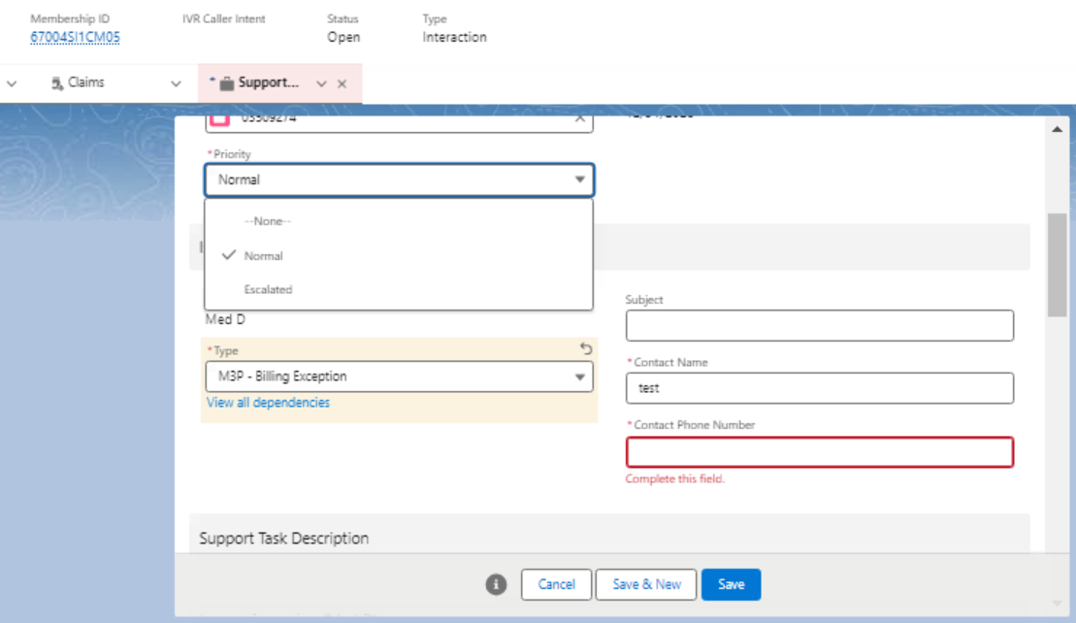

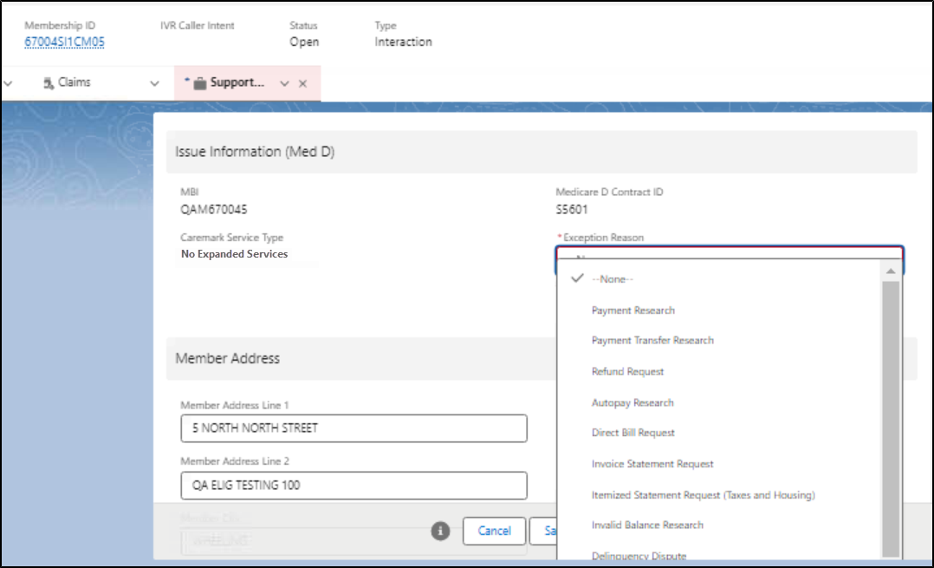

**Notes:**

* **When the** Caremark Service Type field displays **“Expanded Services”, the support task is submitted successfully:**

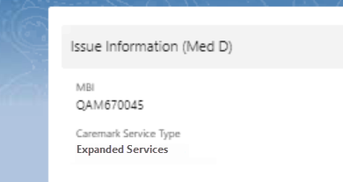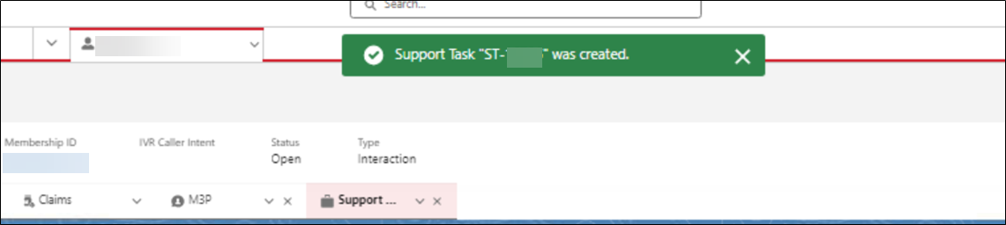

* When the Caremark Service Type field displays “No Expanded Services”, an error message will display when trying to submit the support task:

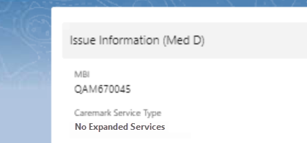 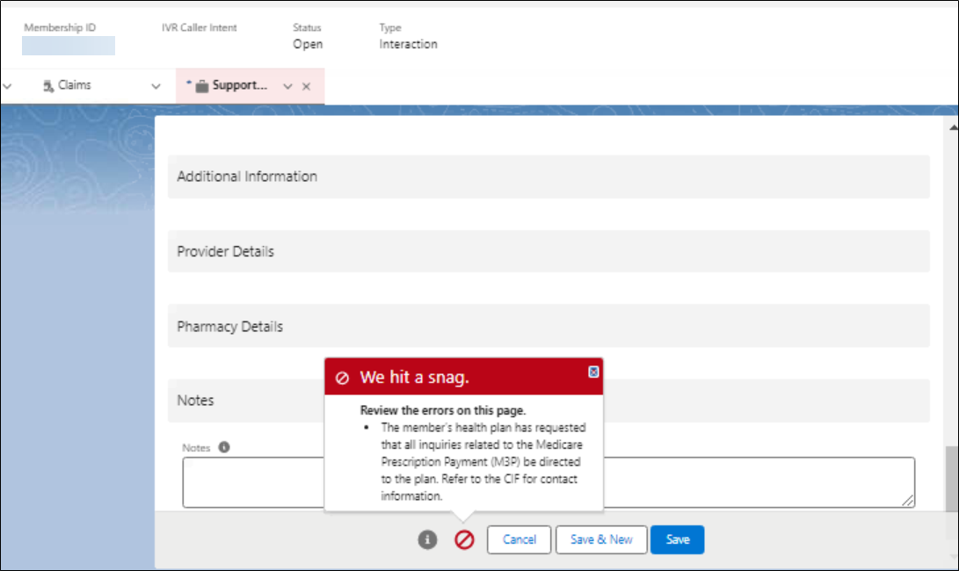

Top of the Document

|  |
| --- |
| Viewing Payment Schedule and Estimating Future Payment Amounts (Forecast) |

The **Payment Schedule & Forecast** tab displays the member’s current monthly payment amounts and the **Forecast** tool.

**Note:** The **Forecast** tool may be used to show estimated future payment amounts when additional prescriptions are added to the Medicare Prescription Payment Plan.

Follow the steps below:

|  |  |
| --- | --- |
| **Step** | **Action** |
| **1** | Click the **Medicare Prescription Payment Plan (M3P)** hyperlink in the **Quick Actions** panel on the Member Snapshot Landing Page.    **Result:** The **M3P** tab will open on the **Summary** tab. |
| **2** | Click the **Payment Schedule & Forecast** sub-tab.    **Result:** The Payment Schedule & Forecast screen displays. |
| **3** | Review the **Payment Schedule** section to advise the member of the current plan year’s monthly member payments.   * If the member wants to make changes to the prescriptions they have included in the Medicare Prescription Payment Plan, the **Forecast** section can be used to estimate future monthly member payments. Proceed to Step 4 as needed. * The payment schedule reflects the member’s current monthly payment amounts, based on claims processed under Medicare Prescription Payment Plan. |
| **4** | Use the **Forecast** section to estimate future Medicare Prescription Payment Plan monthly member payments. Review the **Rx List** and proceed depending on if prescriptions need to be added or removed.   * To remove all prescriptions, click **Reset Rx List**.   **Result:** The Forecasted Payment Schedule table will be removed from the screen.   * To remove individual prescriptions, select the checkbox(es) next to the relevant **Prescription Date** and **Prescription Cost** values, then click **Remove.** * To add prescriptions, enter the required information into the **Prescription Date** and **Prescription Cost** fields, then click **Add to Rx List**. **Notes**:   You can **ONLY** enter prescription dates within the Plan Year displayed at the top of the **Payment Schedule & Forecast** screen.  **Note:** Run test claims as needed to obtain the **Prescription Cost**. |
| **5** | Once the Rx List is updated, click the **Recalculate Forecast** button.  **Result:** The revised forecasted monthly payments will display in the Forecasted Payment Schedule table. |

Top of the Document

|  |
| --- |
| Viewing Payment History |

Follow the steps below:

|  |  |
| --- | --- |
| **Step** | **Action** |
| **1** | Click the **Medicare Prescription Payment Plan (M3P)** hyperlink in the **Quick Actions** panel on the Member Snapshot Landing Page.    **Result:** The **M3P** tab will open on the **Summary** tab. |
| **2** | Click the **Payment History** sub-tab: |
| **3** | Review the payment details information on the **Payment History** tab:   * Invoice Number * Invoice Amount * Bill Due Date * Payment Date * Paid Amount * Applied Amount * Payment Type * Payment Source * Payment Channel * Payment Status   A screenshot of a computer screen  AI-generated content may be incorrect.  **Notes:**   * When hovering over the **Refresh** button, “Refresh Payment History” displays. * If there is no payment history available, the following message displays: “No records found.”   Review any credit and refunds details in the **Credit and Refund History** table that displays below the **Payment History** table:   * Payment Type * Adjustment Amount * Invoice # * Payment Date   A screenshot of a computer screen  AI-generated content may be incorrect. |

Top of the Document

|  |
| --- |
| Viewing Claims History |

**Note:** Invoice PDFs are available from the **M3P Communications** hyperlink in the **Quick Links** panel.

Follow the steps below:

|  |  |
| --- | --- |
| **Step** | **Action** |
| **1** | Click the **Medicare Prescription Payment Plan (M3P)** hyperlink in the **Quick Actions** panel on the Member Snapshot Landing Page.    **Result:** The **M3P** tab will open on the **Summary** tab. |
| **2** | Click the **Claims History** sub-tab: |
| **3** | Review the claim history information on the **Claims History** tab:   * Fill Date * RX # - Clicking the hyperlink will open the **Claims Details** tab for the claim. * Drug Name/Strength * Mbr Pay - Clicking the hyperlink will open the **Financial Details** tab for the claim. * Status |

Top of the Document

|  |
| --- |
| Related Documents |

**Abbreviations/Definitions:** [Customer Care Abbreviations, Definitions, and Terms Index](https://thesource.cvshealth.com/nuxeo/thesource/#!/view?docid=c1f1028b-e42c-4b4f-a4cf-cc0b42c91606)

**Parent Document:** CALL-0048:[Medicare Part D Customer Care Call Center Requirements-CVS Caremark Part D Services, L.L.C.](https://policy.corp.cvscaremark.com/pnp/faces/DocRenderer?documentId=CALL-0048)

Top of the Document

Not To Be Reproduced Or Disclosed to Others Without Prior Written Approval

**ELECTRONIC DATA = OFFICIAL VERSION / PAPER COPY = INFORMATIONAL ONLY**